Choose a title
Your Name
June 19, 2015

Setup
To run this document you will need to install the following packages:
- rmarkdown which allows you to write R Markdown documents and transform them into HTML documents, HTML presentations or Word Document files. You can also create PDF files with it but need other dependencies.
- grid which is used for making some of the fancy plots below. Comes with your R installation.
- plyr which is used for the code of one of the plots.
- devtools for detailed session information.
## Run manually if you need to install these packages
install.packages(c("plyr", "rmarkdown", "devtools"))
TODO
- Install the necessary packages.
- Delete this section.

Cafe wall illusion
All the lines are actually parallel.
library("grid")
rs <- expand.grid(x = seq(0, 1, 1/10), y = seq(0, 1, 1/10))
grid.rect(rs$x, rs$y, 1/10/2, 1/10/2, gp = gpar(fill = "black", col = NA))
grid.rect(rs$x + 1/10/4, rs$y + 1/10/2, 1/10/2, 1/10/2, gp = gpar(fill = "black",
col = NA))
ls <- expand.grid(x = 0:1, y = seq(0, 1, 1/20) - 1/20/2)
grid.polyline(ls$x, ls$y, id = gl(nrow(ls)/2, 2), gp = gpar(col = "grey50",
lwd = 1))
TODO
- Describe what you observe (1 sentence ideally, 2 maximum).
- Hide the code from the output.
- In your description include a link to the Wikipedia page of this illusion using Markdown syntax.

Un-named
nx <- 6; ny <- 6; lwd <- 10; cr <- 1/100
grid.newpage()
grid.rect(0.5, 0.5, 1, 1, gp = gpar(fill = "black"))
ls <- expand.grid(x = 0:1, y = seq(0, 1, 1/nx/2) - 1/nx/2/2)
grid.polyline(ls$x, ls$y, id = gl(nrow(ls)/2, 2), gp = gpar(col = "grey", lwd = lwd))
ls <- expand.grid(y = 0:1, x = seq(0, 1, 1/ny/2) - 1/ny/2/2)
grid.polyline(ls$x, ls$y, id = gl(nrow(ls)/2, 2), gp = gpar(col = "grey", lwd = lwd))
ls <- expand.grid(x = seq(0, 1, 1/nx/2) - 1/nx/2/2, y = seq(0, 1, 1/ny/2) - 1/ny/2/2)
grid.circle(ls$x, ls$y, r= cr, gp = gpar(col = NA, fill = "white"))
TODO
- Describe what you observe (1 sentence ideally, 2 maximum).
- Hide the code from the output.
- Choose a new name for the illusion and update the section title as well as the chunk description (remember to keep the quotes!).

Ouchi
Move your frame of reference to see the effect.
grid.newpage()
nx <- 10
ny <- 30
rs <- expand.grid(x = seq(0, 1, 1/nx/2), y = seq(0, 1, 1/ny/2))
grid.rect(rs$x, rs$y, 1/nx/2, 1/ny/2, gp = gpar(col = NA, fill = c("black",
"white")))
rs <- expand.grid(x = seq(0.25, 0.75, 1/nx/2), y = seq(0.25, 0.75, 1/ny/2))
grid.rect(rs$y, rs$x, 1/ny/2, 1/nx/2, gp = gpar(col = NA, fill = c("black",
"white")))
TODO
- Describe what you observe (1 sentence ideally, 2 maximum).
- Hide the code from the output.

Fraser illusion
All the lines are actually parallel.
library("plyr")
grid.newpage()
n <- 10
ny <- 8
L <- 0.01
c <- seq(0, 1, length = n)
d <- 1.2 * diff(c)[1]/2
col <- c("black", "white")
x <- c(c - d, c, c + d, c)
y <- rep(c(0, -d, 0, d), each = n)
w <- c(c - d, c - d + L, c + d, c + d - L)
z <- c(0, L, 0, -L)
ys <- seq(0, 1, length = ny)
grid.rect(gp = gpar(fill = gray(0.5), col = NA))
l_ply(1:ny, function(i) {
n
if (i%%2 == 0) {
co <- rev(col)
z <- -z
} else {
co <- col
}
grid.polygon(x, y + ys[i], id = rep(1:n, 4), gp = gpar(fill = co, col = NA))
grid.polygon(w, rep(z, each = n) + ys[i], id = rep(1:n, 4), gp = gpar(fill = rev(co),
col = NA))
})
TODO
- Describe what you observe (1 sentence ideally, 2 maximum).
- Hide the code from the output.

Fraser-Wilcox illusion
grid.newpage()
No <- 3
wo <- 1/3/2
po <- seq(0, 1, by = wo)[(1:No) * 2]
Nc <- 8
tc <- seq(pi * 11/12, pi * 1/12, len = Nc)
px <- c(outer(wo * cos(tc), po, `+`))
wc <- rep(sin(tc), No)
ag <- rep(1:No, each = Nc)
dc <- 21
th <- seq(0, 2 * pi, len = dc)
grid.rect(gp = gpar(col = NA, fill = "#D2D200"))
for (y0 in seq(0, 1, len = 10)) {
for (i in seq_along(px)) {
th <- seq(pi/2, pi/2 + 2 * pi, len = 21)
if (ag[i]%%2 == 0)
th <- rev(th)
x <- px[i] + 0.5 * 0.04 * cos(th) * wc[i]
y <- y0 + 0.04 * sin(th)
grid.polygon(x, y, gp = gpar(fill = "#3278FE"))
grid.polyline(x[1:((dc + 1)/2)], y[1:((dc + 1)/2)], gp = gpar(lineend = "butt",
lwd = 3, col = gray(0)))
grid.polyline(x[-(1:((dc - 1)/2))], y[-(1:((dc - 1)/2))], gp = gpar(lineend = "butt",
lwd = 3, col = gray(1)))
}
}
TODO
- Describe what you observe (1 sentence ideally, 2 maximum).
- Hide the code from the output.

Parallel curves
These curves are the same offset apart for every x, even though it looks like they converge.
x = 1:100
y = 1/log10(x)
y2 = y + 0.2
plot(x, y, type = "l", ylim = c(0, 1.5))
lines(x, y2)
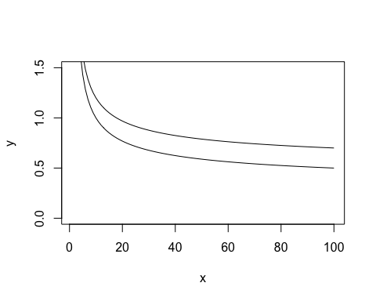
TODO
- Describe what you observe (1 sentence ideally, 2 maximum).
- Hide the code from the output.

蛇の回転錯視
Google translate: rotation illusion of snake
nt <- 41; nr <- 15; br <- 0.8
col1 <- c("black", "white")
col2 <- c("aquamarine4", "gold2")
f <- function(x0, y0) {
r <- embed(br^(0:nr), 2)
t <- embed(seq(0, 2*pi, length=nt), 2)
i <- as.matrix(expand.grid(1:nrow(r), 1:nrow(t)))
ci <- 1 + (i[,2]%%2 + i[,1]%%2) %% 2
p <- t(apply(i, 1, function(x) c(r[x[1], ], t[x[2], ])))
x <- c(p[,1]*cos(p[,3]), p[,1]*cos(p[,4]), p[,2]*cos(p[,4]), p[,2]*cos(p[,3]))
y <- c(p[,1]*sin(p[,3]), p[,1]*sin(p[,4]), p[,2]*sin(p[,4]), p[,2]*sin(p[,3]))
grid.polygon(x0+x/2, y0+y/2, id = rep.int(1:nrow(p), 4),
gp = gpar(fill = col1[ci], col=NA), default.units="native")
p <- expand.grid(1:nrow(r), sign((abs(x0-y0)==1)-0.5)*seq(0, 2*pi, length=41)[-1])
p <- cbind(p[,2], rowMeans(r)[p[,1]], (r[,2]-r[,1])[p[,1]]/2)
t <- seq(0, 2*pi, length=20)[-1]
x <- c(apply(p, 1, function(a) a[2]*cos(a[1])+a[3]*(cos(a[1])*cos(t)-0.5*sin(a[1])*sin(t))))
y <- c(apply(p, 1, function(a) a[2]*sin(a[1])+a[3]*(sin(a[1])*cos(t)+0.5*cos(a[1])*sin(t))))
col <- if(abs(x0-y0)==1) {col2} else {rev(col2)}
grid.polygon(x0+x/2, y0+y/2, id = rep(1:nrow(p), each=length(t)),
gp = gpar(fill = col[ci], col=NA), default.units="native")
}
grid.newpage()
pushViewport(viewport(xscale = c(0, 3), yscale = c(0, 3)))
for (x0 in 0.5+0:2) for (y0 in 0.5+0:2) f(x0, y0)
for (x0 in 1:2) for (y0 in 1:2) f(x0, y0)
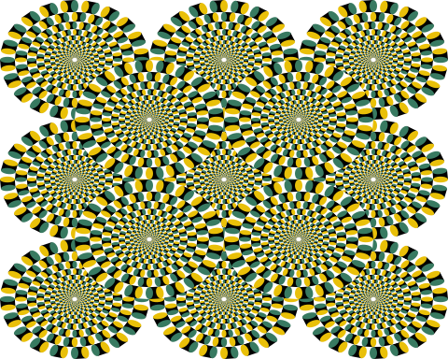
TODO
- Describe what you observe (1 sentence ideally, 2 maximum).
- Hide the code from the output.
- Translate the Japanese section title into English.

References
Based on the illusions knitrBootstrap vignette which itself is based on Kohske Takahashi's code at http://rpubs.com/kohske/R-de-illusion.

Reproducibility
TODO
- Add an R code chunk showing the reproducibility information. Use the session_info() function from the devtools package.
- Hide the code from the output.
- Use an R inline code to show the date the report was generated. Use the Sys.time() function to get the date. Remember that R inline code is useful if you want to automatically include numbers or other results in your document.

